Shop Keeper Application Test
S/N | Action | Issue
1 | From home page, Clicking the “Register” link | Shows compilation error shown in Fig.
2 | Clicking the “Login” link | Shows server error shown in Fig 2 and continuation in Fig 3
3 | Clicking on Master>Dashboard | Nothing is displayed yet
4 | Clicking on Master>Packages>Subscriber | Nothing is displayed yet
5 | Clicking on Master> Transaction> New Transaction | Nothing is displayed yet
6 | Clicking on Master> Transaction> Transaction history | Nothing is displayed yet
7 | Clicking on Master> Transaction> Exchange Rate | Nothing is displayed
8 | Clicking on Master> General Settings> Banks | Only 9 banks are currently added out of all the banks in Nigeria. Fig. 4
9 | Clicking on Master> General Settings> Countries | Only 7 countries are currently shown Fig 5
10 | Clicking on Master> General Settings> Cities | Only 3 cities are currently shown Fig 6
11 | Clicking on Master> General Settings> Currency | Only 2 currencies are currently displayed Fig 7
12 | Clicking on Master> Support> FAQ | Nothing is displayed yet
13 | Clicking on Master> Support> Service Request | Nothing is displayed yet
14 | From home page clicking on Store> Dashboard> My sales | “My sales” drop down link cannot be accesses Fig 8
15 | Clicking on Store> POS | “New Transaction” and “Sales Log” cannot be accessed Fig 9
16 | Clicking on Store> Services | Nothing is displayed yet
17 | Clicking on Store> My Subscription> Settings | Nothing is displayed yet

Figure 1
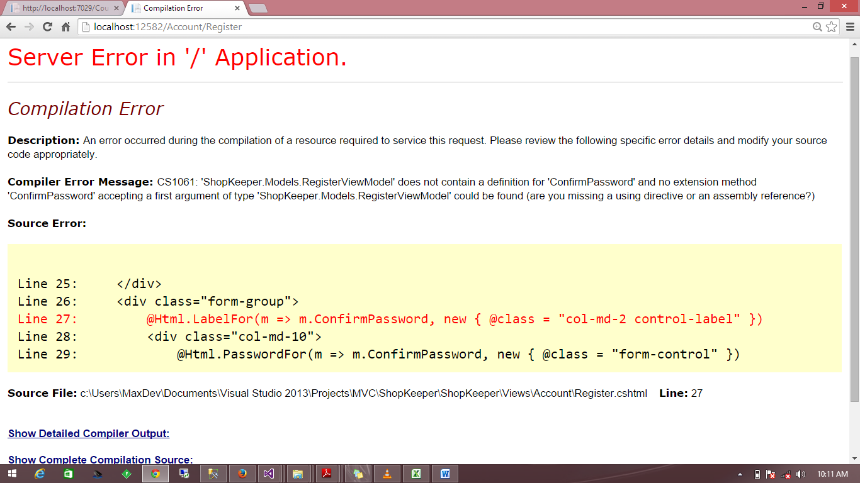

Figure 2
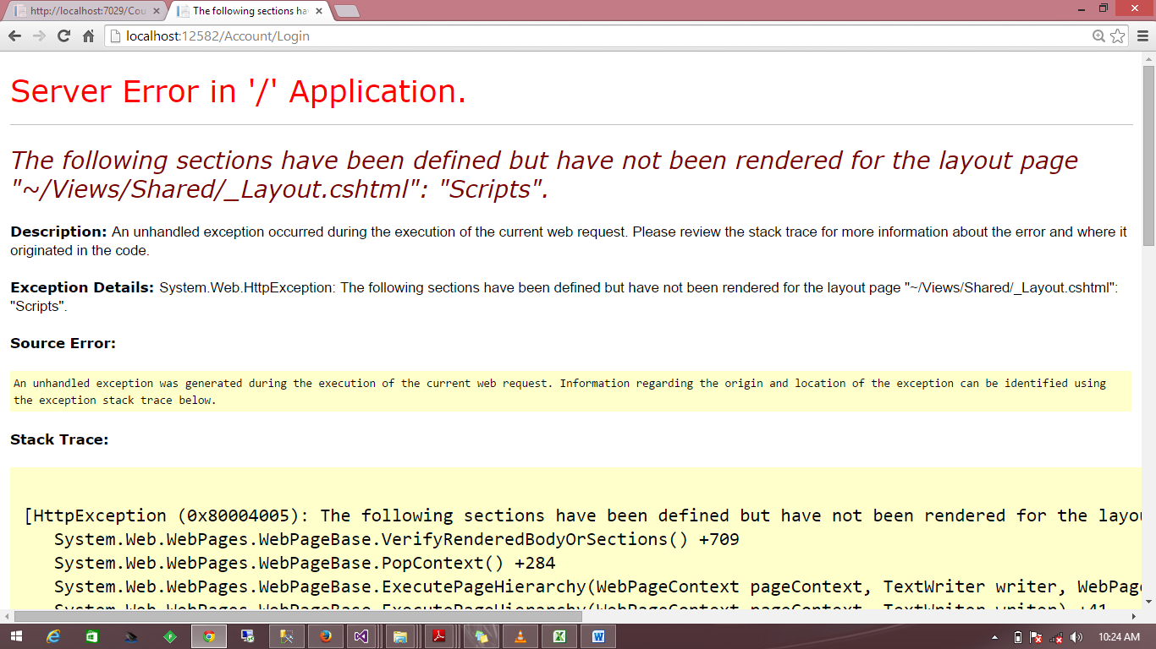

Figure 3
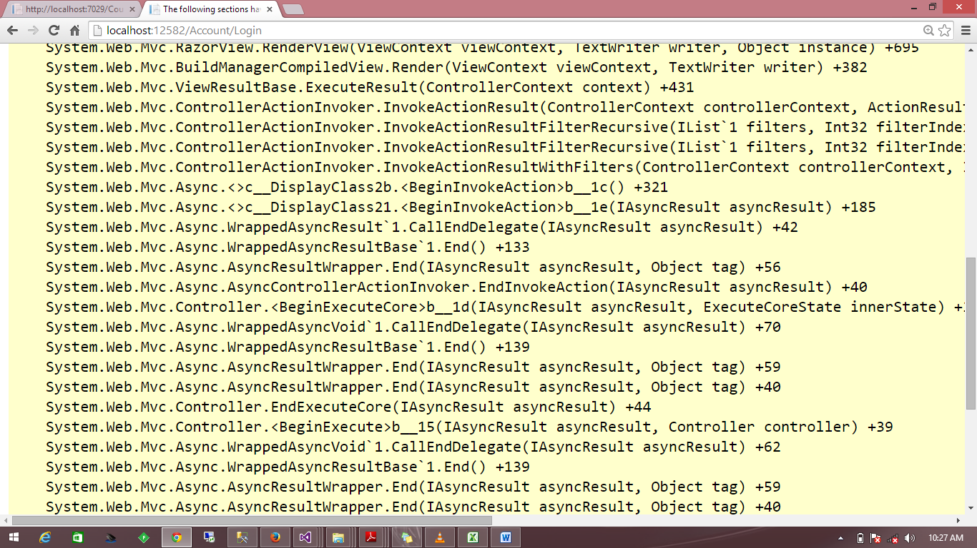
Figure 4
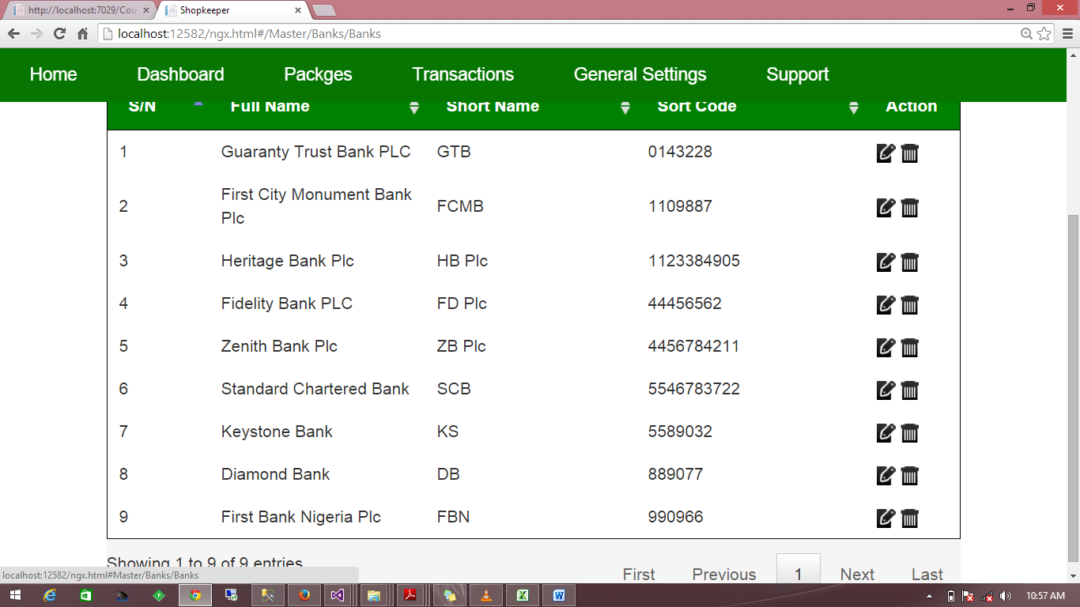

Fig 5
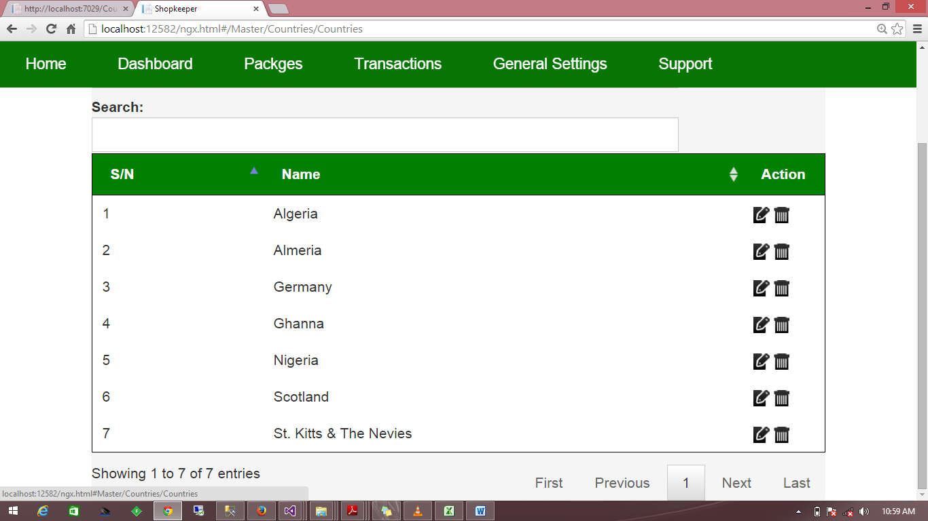
Fig 6
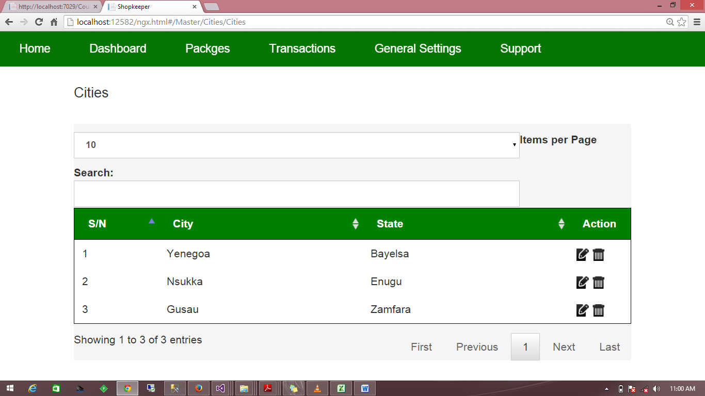

Fig 7
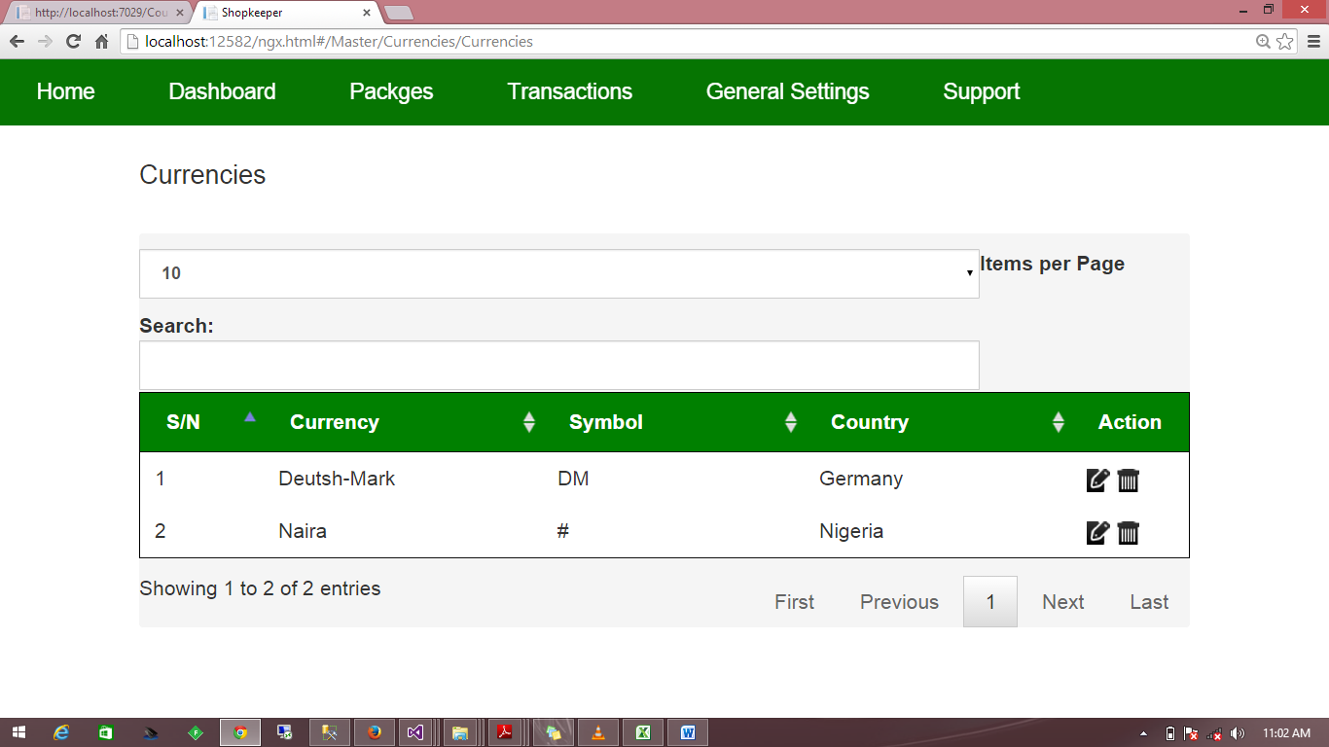
Fig 8
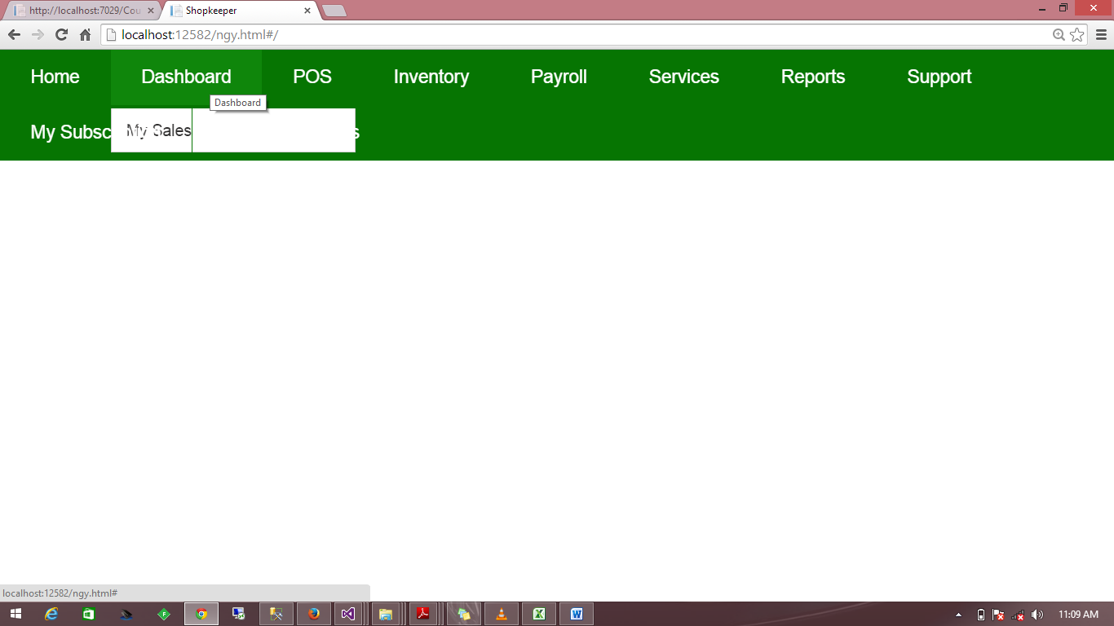

Figure 9
